The Decibel (dB)
Phil Wait, RedRoo Kits
When working in any type of signal engineering it’s not long before you encounter the term decibel (dB) to show the ratio between two powers, or other quantities such as voltage, current, field strength, or sound pressure, etc.
The decibel was devised by Bell Systems in the US to measure signal power in telephone networks. It is a very useful measure because it is based on a logarithmic scale, and therefor has the ability to show small changes within a very large range. Human hearing and vision have a near logarithmic response to strength and intensity, so decibels also relate well to human perceptions of light and sound.
The decibel is used in a very wide variety of electronics, communications and sound engineering applications, as it is a very convenient way to describe a change in value such as the gain of an amplifier, the sensitivity of a loudspeaker, the loss through an attenuator, the shape factor of a filter, the efficiency of an antenna, the signal to noise ratio or the noise factor of a receiver, or anywhere a comparative logarithmic scale is appropriate.
It can have either a positive or a negative sign, such as –dB or +dB

Decibels as a power ratio or sound intensity
When expressing the ratio of two powers or sound intensities, the formula is:

$$dB =10\log\left(\frac{P1}{P2}\right)$$

A change in power by a factor of 10 corresponds to a change of 10dB, 100 times is 20dB, 1000 times is 30dB, etc.
A doubling of power is +3dB, and a halving of power is -3dB.
A sound intensity variation of 1dB is a 26% increase in power, but it is barely noticeable to a human. For instance, the difference between an 80 Watt amplifier and a 100Watt amplifier might sound like a worthwhile increase in the specifications, but it probably wouldn’t be noticeable. (If you want to purchase a more powerful amplifier, go for an increase of at least four times to make the exercise worthwhile).

Decibels as a voltage or current ratio
When expressing the ratio of two voltages or sound pressures, the formula is:

$$dB =20\log\left(\frac{V1}{V2}\right)$$

A change in voltage by a factor of 10 corresponds to a change in level of 20dB, 100 times is 40dB, 1000 times is 60dB, etc.
A doubling of voltage is +6dB, or a halving voltage is -6dB.

The multipliers of 10 and 20 corresponding to voltage/current and power are very convenient because an (x)db increase in either voltage or current will cause in the same (x)dB increase in power. An (x)dB increase in both voltage and current will cause a 2(x)dB increase in power.

The decibel also allows the addition or subtraction of gains and losses through each part of a system. For instance:

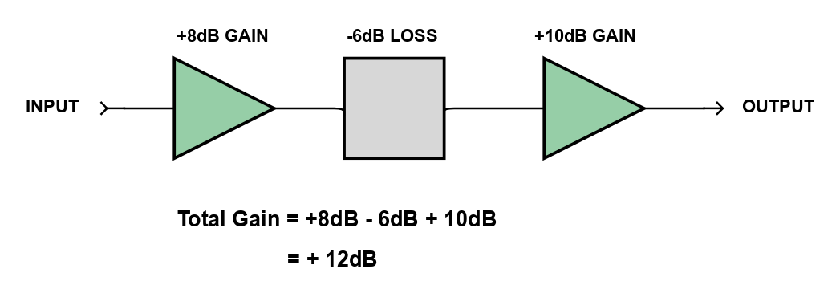

Decibels referenced to an absolute value
Decibels can also show an absolute value, by describing amplitude as a number of decibels above or below a reference level. For instance, dBm is the decibel ratio of power above or below one milliwatt, originating from Bells original telephony applications where one milliwatt is a commonly used signal level.
Some commonly used decibel levels are listed below:

dBm | 0dBm is 1mW
dBW | 0dBW is 1 Watt
dBuV | 0dBuV is 1 microvolt
dBV | 0dBV is 1 Volt
dB(μV/m) | Electric field strength relative to 1 microvolt per meter.
dB (SPL) | Sound pressure level where 0dB SPL is the quietest sound an average human can hear.
dBA  dBB  dBC | Variations of SPL using frequency weighting filters to approximate a human ears response to sound.
dB(i) | The gain of an antenna compared to a hypothetical isotropic antenna (a perfect antenna that radiates power uniformly in all directions).
dB(d) | The gain of an antenna compared to a perfect half wave dipole.  0dB(d) = 2.15 dB(i)
dB(C) | The relative level of noise or sideband power compared to carrier power in a transmitted signal.

